**TODO List**

As shown in the below UI User will be able to add their to do task by entering in the textbox and clicking on the add button.

Multiple tasks can be added to the list.

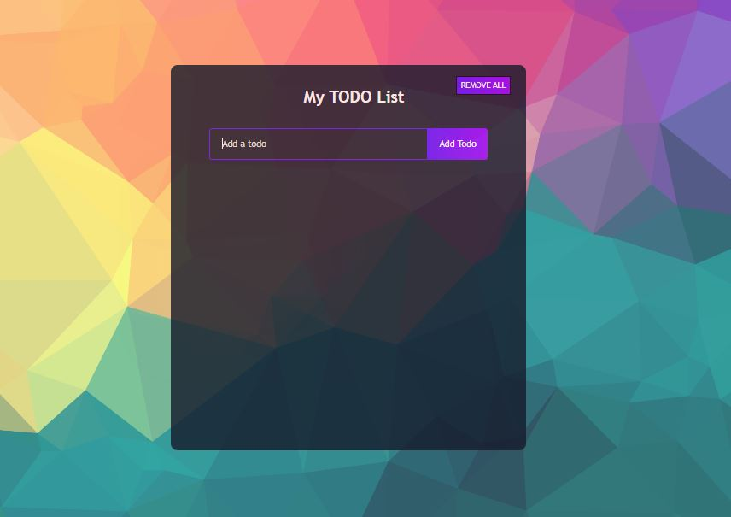

As shown in the below image where 5 tasks are added in the list

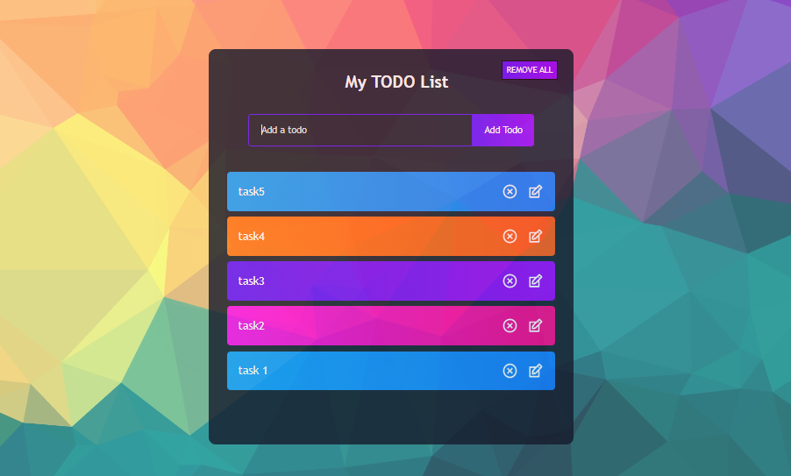

Users can remove their items by clicking on the cross icon and also can update their existing tasks by clicking on the modify icon next to the cross icon.

In the below Image user is editing their task 5.

On the shown screen users can add a new task, remove all tasks and Update an existing task as well.

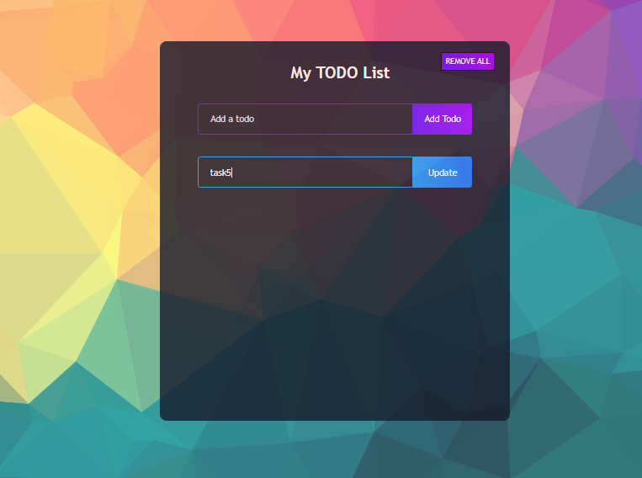

When a user wants to mark a task as completed or off the list then they can simply click on the task text so that the item will have a strikethrough applied and at the same time the item will move at the bottom of the list. Refer below image for the same

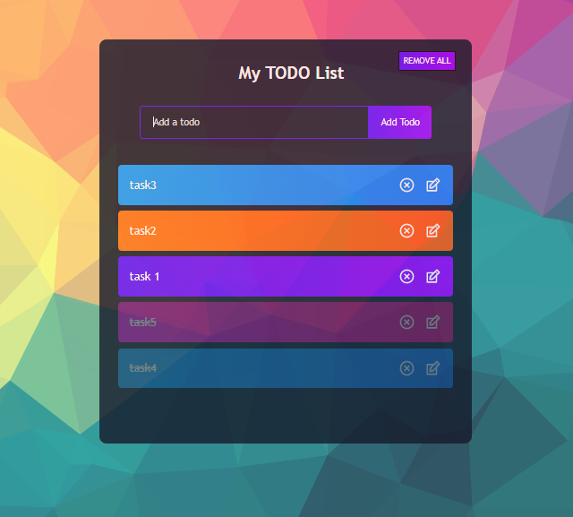

**Note** :

1. Users can enter “n” number of characters while adding/updating an item in the textbox.
2. Data is stored in the local storage even if hard reload is done the data doesn’t reset.
3. While updating if the user clicks on remove all then all list items will be removed and nothing will be updated.
4. Users will be able to remove/update their completed task. If completed task is updated then it will still be marked as completed